

MEDICAL EQUIPMENTS RANGE FROM PEACOCK MEDICINE

Peacock Medicine aims to be a one stop solution for sourcing of Hospital Consumption products ranging from high end equipments of Medical Imaging to products of day to day consumption like Disposable Syringes,
Dressings, Surgical Disposables , Catheters, Canulas, etc.
Peacock Medicine brings to its valuable clients wide spectrum of hospital range of products having valid certifications like CE, FDA etc.
Some of the products range dealt by Peacock Medicine are mentioned hereunder.
P.S.: Besides products mentioned above, peacock medicine has an expertise in sourcing products as per requirements of its hospital clients.
So please feel free to share with us your specific product requirements.
Our team will get back to you with latest offerings at competitive prices.

Medical Imaging
- Ultrasound Machine
- Mammography System
- Colposcope
- X-Ray Machine
- CT SCAN
- C-Arm, Nuclear Imaging Systems
ICU Equipment
- Ventilator
- CPAP System
- BPAP System
- Patient Monitor
- Infusion Pump
- Syringe Pump
- Blood Warmer
- Defibrillator
OT Equipment
- Ceiling Pendants
- Electrosurgical Unit
- OT Lights
- OT Tables
Specialized Hi tech Equipments
- Heart-Lung Machine,
- Surgical, CO2 Monitor,
- Patient Monitor,
- Pulse Oximeter,
- AED Defibrillator,
- Cath Labs,

Endoscopy
- Infant Care Product
  - Warming Systems
    - Comprehensive Infant Care Centre
    - Neonatal Resuscitation Care
    - Infant Radiant Warmer
    - Infant Radiant Warmer
    - Open Care Warmer
  - Incubators
    - Neonatal Intensive Care Incubator
    - Transport Incubator
    - Neonatal Intensive Care Incubator INC 200
Ventilator
  - Fabian HFO
  - Fabian Evolution

Jaundice Management
- LED Phototherapy Unit
- "Brilliance" LED Phototherapy Unit
- CFL Phototherapy Unit
- Double Surface Phototherapy Unit
- Phototherapy Eye Mask
Respiratory
- Resuscitation Bag
- Nasal CPAP Unit
- NCPAP 300
Others
- Electronic Baby Weighing Scale
- Infant Bassinet
- Oxygen Hood
- Apnea Monitor/Oxy Monitor

ENT
ENT Work Stations
Microdebriders
Bronchoscope
General Hospital Furniture

Hi – Low ICU Bed / Fowler Bed/ Semi - Fowler Bed
Pediatric Bed/ Labor Table
Emergency Trolley / S.S. Patient Trolley
Patient Trolley / Folding Wheel Chair
Non - Folding Chair / Three Fold Screen
Revolving Stool with S.S. Top / Revolving Stool with Cushion

Bed Side Locker / Cylinder Trolley
Gear Over Bed Table / Over Bed Table
S.S. Mayo’s Table / S.S. Instrument Table
S.S. Dressing Table/ S.S. Crash Cart
Foot Steps/ I.V. Stand

SUTURES
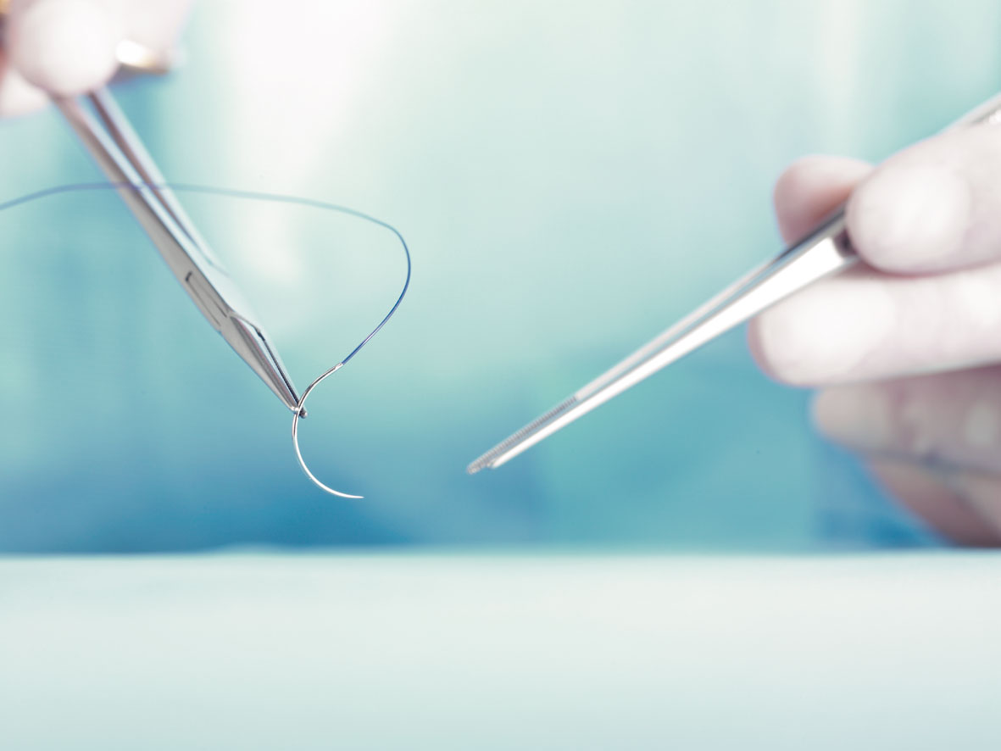

Face Masks , Gloves & Gowns
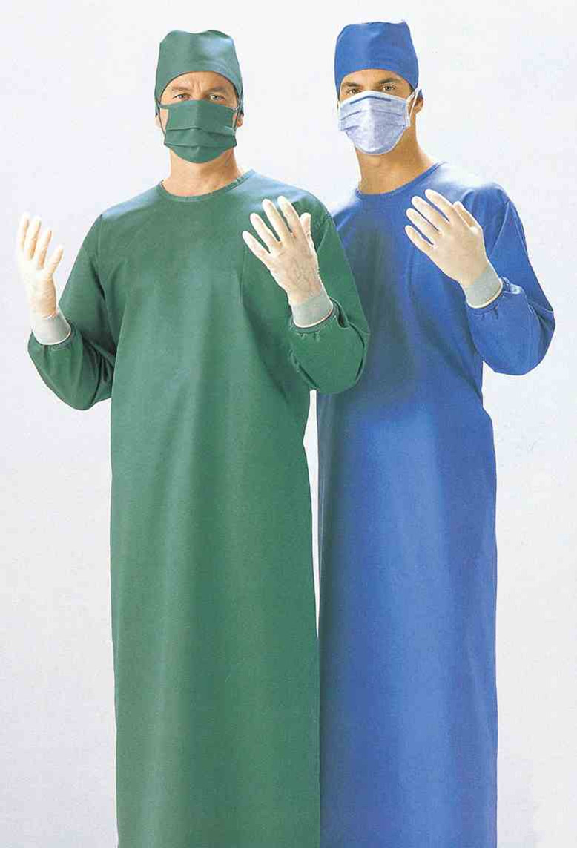

CURTAINS

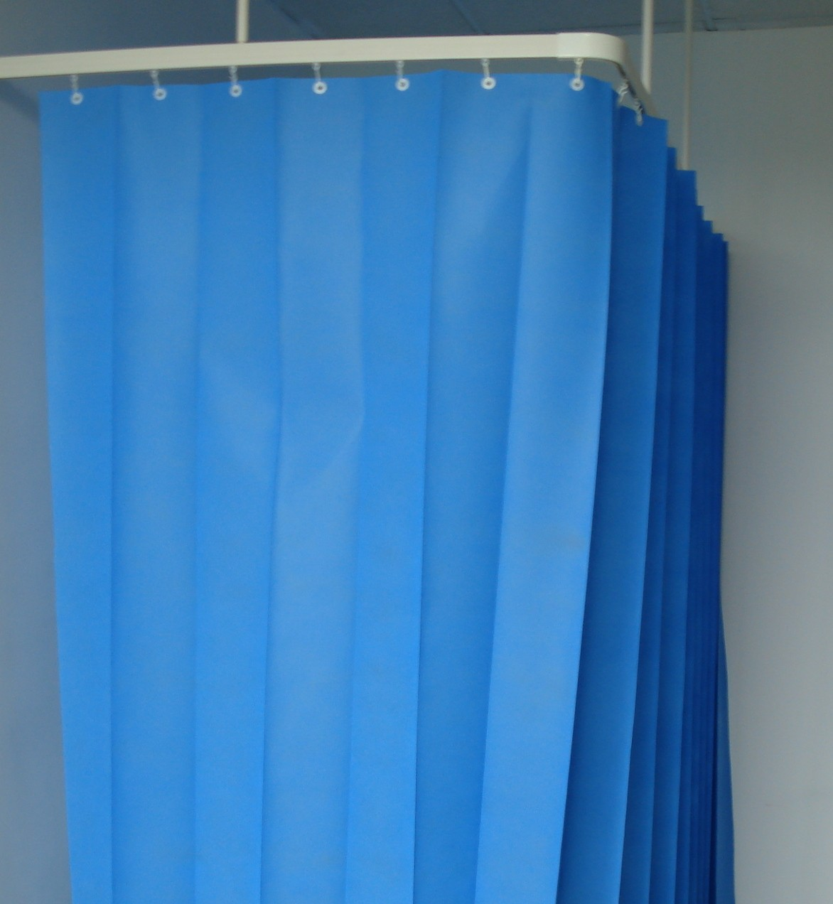

GLOVES
Examination Gloves
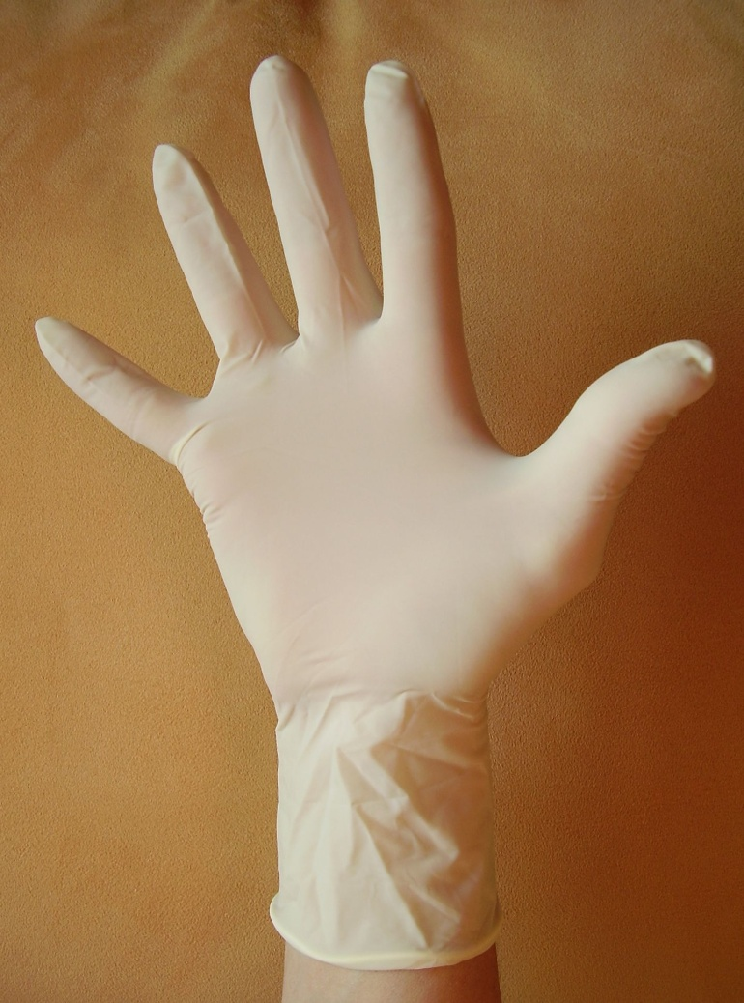

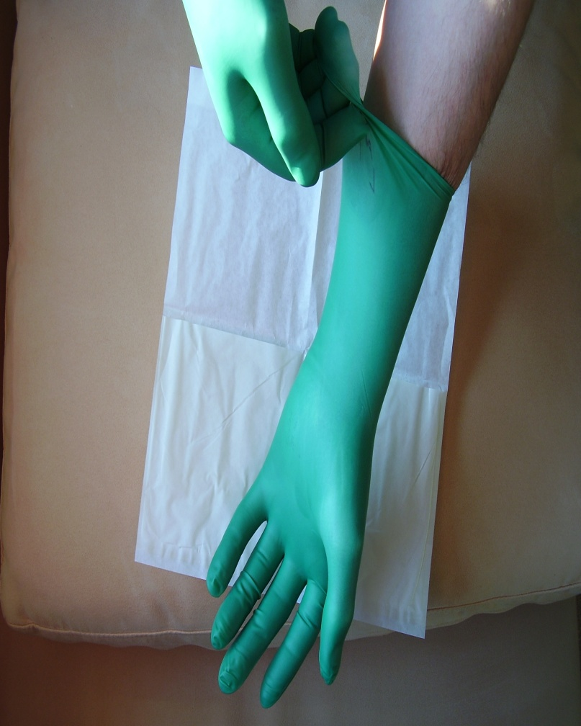
Surgical Glove

Hospital Linens


HOSPITAL BEDS
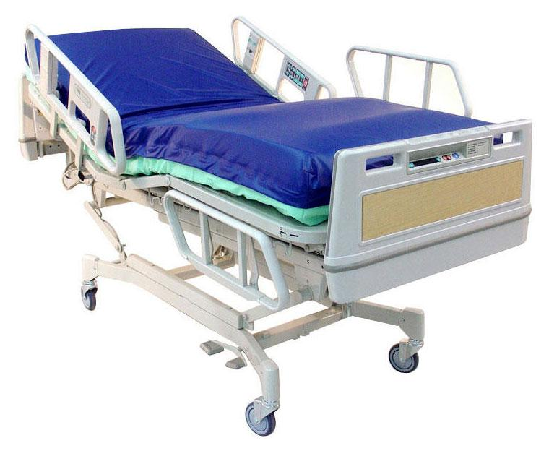
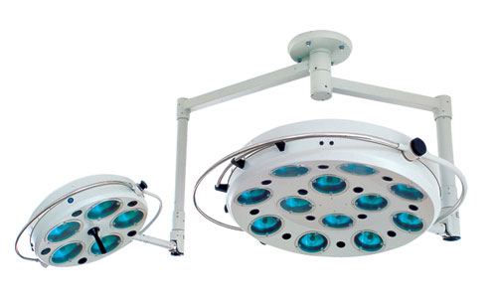
Spinal Needle

Epidural Needles

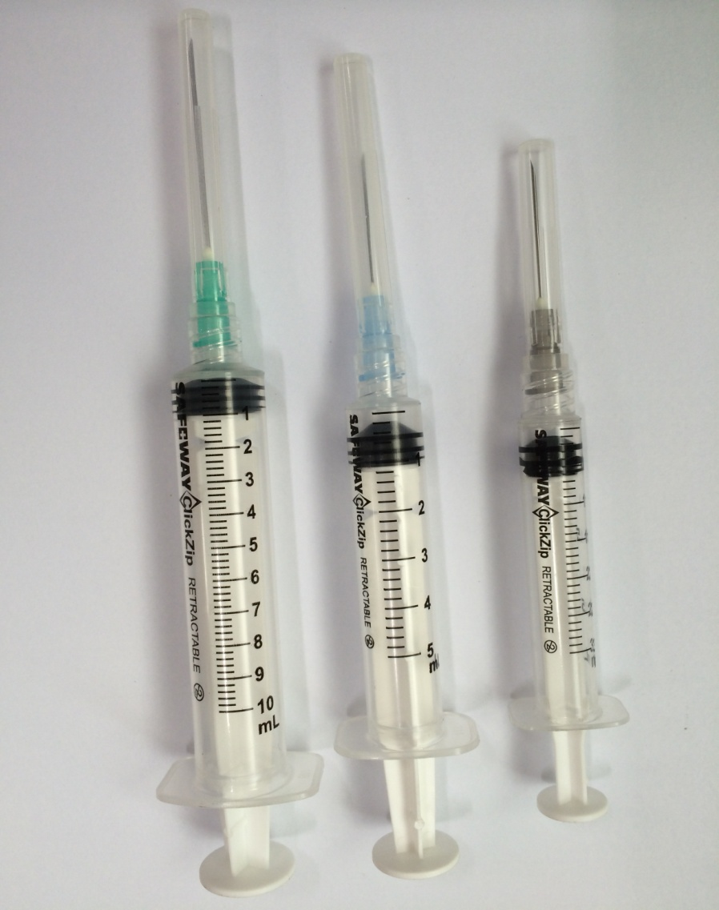

DISPOSABLE SYRINGES

Contact :

Cell : +919818715764
+91 8744879418

E Mail : info@peacockmedicines.com
sahil.mforu@live.in
peacockmedicine@gmail.com
website : www.peacockmedicine..com

